## COSSIM GUI Installation Guide

COSSIM-Wizard for the simulation configuration, and the execution monitoring tool have been implemented as plugins into the OMNET++ environment. The Plug-in Development Environment offers an exporting mechanism in order to create .jar executable files [1]. In the *Overview* tab of the manifest editor, which appears by opening a file from the META-INF Directory in the plugin project (MANIFEST.MF, build.properties or plugin.xml), using the *4.Export the plug-in in a format suitable for deployment using the Export Wizard,* the executable .jar file of the plugin can be exported in the specified directory in the *Destination* tab as illustrated in Figure 1 & Figure 2.

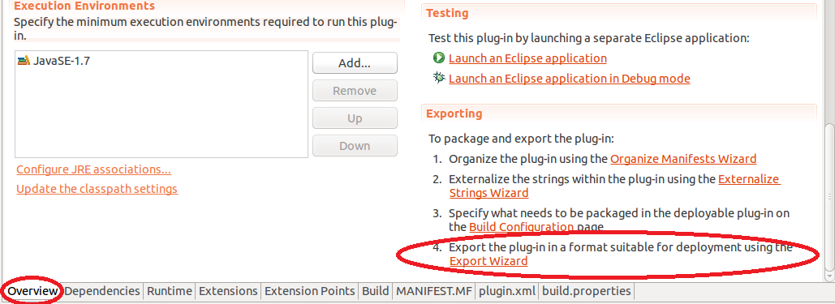

Figure 1. The Overview tab of manifest editor

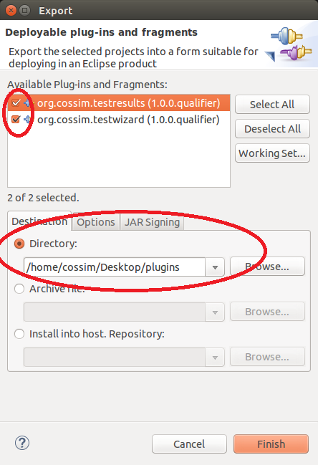

Figure 2. Export wizard for .jar files

In order to export both the configuration wizard and the monitoring tool, the check boxes in the top of the export wizard must be checked. Once the .jar files have been created, they must be copied in the <omnetpp-installation>/ide/dropins directory. By restarting the OMNET++, the .jar files will be recognized by OMNET++ environment.